WEATHER CLIMATE WATER |   World Meteorological Organization  COMMISSION FOR OBSERVATION, INFRASTRUCTURE AND INFORMATION SYSTEMS  Second Session  Geneva, 24 to 28 October 2022 | INFCOM-2/Doc. 7.4(1)
Submitted by:
Chair of SC-MINT
20.IX.2022
DRAFT 1
AGENDA ITEM 7: PROCEDURAL AND COORDINATION ASPECTS
AGENDA ITEM 7.4: Publication policy

process for publication of technical document series
Summary
Document presented by: Chair of SC-MINT
Strategic objective 2020–2023: In line with strategic objective 2.1
Financial and administrative implications: within the terms of reference of INFCOM and its standing committees, within parameters of the Strategic and Operational Plans 2020–2023, will be reflected in the Strategic and Operational Plans 2024–2027.
Key implementers: INFCOM Management Group.
Time frame: 2022–2027
Action expected: Clarify and harmonize processes applying for approval of INFCOM-related publication series.

DRAFT DECISION

Draft Decision 7.4(1)/1 (INFCOM-2)

Process for publication of technical document series
The commission for observation, infrastructure and Information systems
Welcomes the process for submission, review, and approval of the Instruments and Observing Methods reports, as provided in the annex, which clearly describes the process in place;
Supports the use of this process for the publication of Instruments and Observing Methods reports;
Requests its Management Group to consider the implementation of similar processes to the other relevant INFCOM-related publication series;
Further requests its Management Group to collaborate with SERCOM and the Research Board to move towards a harmonized submission, approval, and publication policy for the publication of the WMO non-regulatory publication series.
_______
Decision justification: The series of Instruments and Observing Methods (IOM) reports has a long history with already 136 publications available. The reports present important records of intercomparisons, field tests, specifications, guidelines, and experience-sharing originating from activities and projects related to the instruments and methods of observation. The material available in the reports provides detailed, specific, additional information to the core material available in the Guide to Instruments and Methods of Observation (WMO-No. 8).
The approval and publications process had been established long ago and the mandate for approval of the reports was successfully transferred from the president of the Commission for Instruments and Methods of Observation (CIMO) to the president of the Commission for Observation, Infrastructure and Information Systems (INFCOM). However, the entire process has never been fully described and documented. It is envisaged that the formalization and detailed description of the process for submission, review, and approval of the IOM reports as presented in the annex will clarify the process and help in the harmonization of similar processes that are in place within INFCOM, and in other WMO bodies.
_______________

Annex to draft Decision 7.4/1 (INFCOM-2)
Process for submission, review and approval of the
Instruments and Observing Methods reports
- Background
1.1 This document provides guidance on the submission, review, and approval of Instruments and Observing Methods (IOM) reports. The intended audience is the SC-MINT Editorial Board and IOM authors.
1.2 IOM reports provide a consistent method for recording detailed information in addition to the core material found in the Guide to Instruments and Methods of Observation (WMO-No. 8), for specific audiences. They are important records of intercomparisons, field trials, specifications, and detailed analyses of metrological issues.
1.3 The Standing Committee on Measurements, Instrumentation, and Traceability (SC-MINT) of the WMO Commission for Observation, Infrastructure, and Information Systems (INFCOM) has overall responsibility for the vetting and publication of the IOM series of reports.
1.4 In practice, an Editorial Board (EdBd) established by SC-MINT will organize and realize a review of documents submitted for consideration as IOM reports.
- Attachments
- IOM report review and approval process flowchart.
- IOM report submission form.
- SC-MINT Editorial Board (EdBd) IOM report submission-tracking form.
- Submissions
- Submission of candidate IOM reports are welcomed from any expert or expert team/ group willing to share their knowledge and experience originating from activities and projects related to Instruments and Observing Methods.
- Submissions must be emailed to the WMO Secretariat (see contact details of SC-MINT Secretariat support staff on the SC-MINT website) along with a completed IOM report submission form. The submission form is available through the IMOP website.
- Evaluation will commence as soon as a sound draft report is submitted and will follow the process summarized in the attached diagram below.
- Responsibilities
- SC-MINT, with the support of the WMO Secretariat, is responsible for the intake of draft IOM reports and their initial formal review, passing to the EdBd for detailed review, progressing the final EdBd-reviewed report through its final approval by the President of INFCOM, and initiating the publishing process once the final report is fully approved.
- The Editorial Board is responsible for: coordination of the evaluation, both internally and by the technical reviewer(s), for communication with the author during the review steps, and consulting closely with the WMO Secretariat as needed during the review steps.
- General Evaluation Steps
The steps below summarize the evaluation process and are illustrated in the attached diagram.
- A draft IOM report can be submitted by the author to the WMO Secretariat, along with a completed IOM report submission form. The form will be reviewed by the WMO Secretariat for completeness and appropriateness, and either registered or returned to the author to have any issues addressed. Once registered, the draft report and tracking form are forwarded to the EdBd IOM Lead.
- The EdBd IOM Lead, who becomes the point of contact for the author during assessment steps, reviews the report for completeness and suitability and, if necessary, returns it to the author(s) for amendment.
- If the report is ready for review, the EdBd IOM Lead, in consultation with the WMO Secretariat, proposes reviewers. A minimum of two reviewers are proposed for approval by SC-MINT, including one editorial reviewer from the EdBd and one or more subject matter expert technical reviewers who are independent of the author group.
- Once reviewers’ comments are received, they are considered by the EdBd. The draft may iterate between the authors and the EdBd IOM Lead for clarification or adjustments until the EdBd assesses that it is suitable for publication.
- The EdBd IOM Lead submits the final draft to the WMO Secretariat for SC-MINT review and endorsement.
- An endorsed draft is then submitted to the President of INFCOM for final approval.
- Once approved, the WMO Secretariat initiates the WMO publishing process and informs the EdBd IOM Lead of completion.
- Finally, the EdBd IOM Lead informs the IOM report author(s) of the outcome, closes the tracking process and archives all review materials.
Throughout this process, details will be recorded on the SC-MINT Editorial Board (EdBd) IOM report submission-tracking form.

Attachment 1: IOM report review and approval process flowchart
(For additional details, see accompanying text)
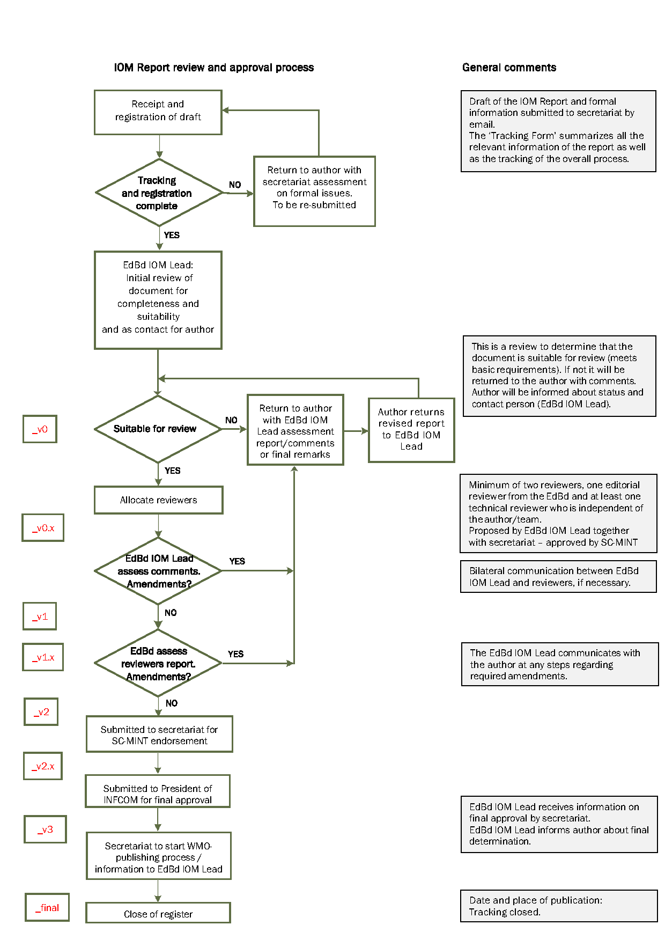
Attachment 2: IOM report submission form

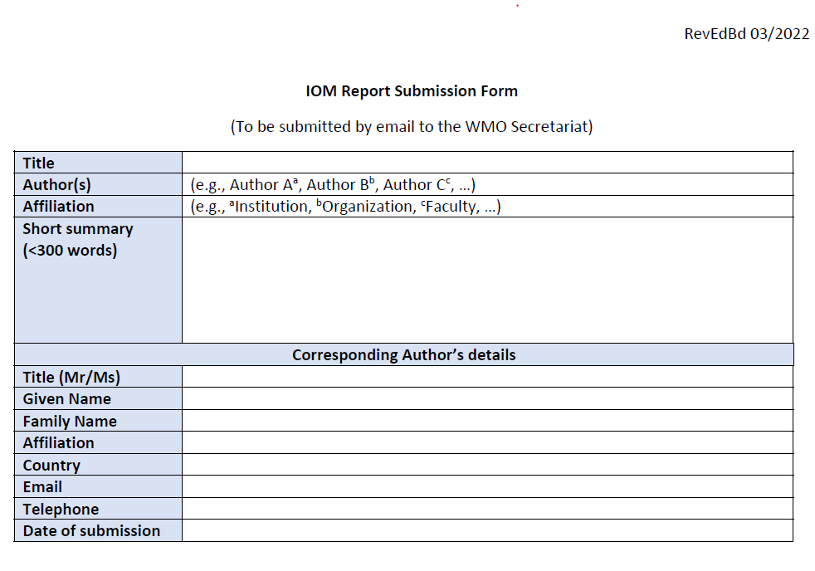

Attachment 3: SC-MINT Editorial Board (EdBd)
IOM report submission-tracking form
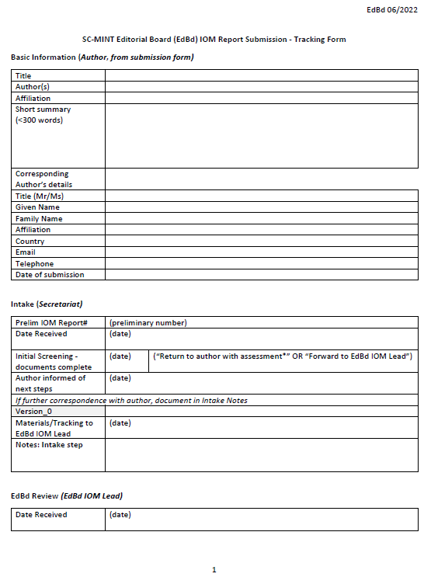

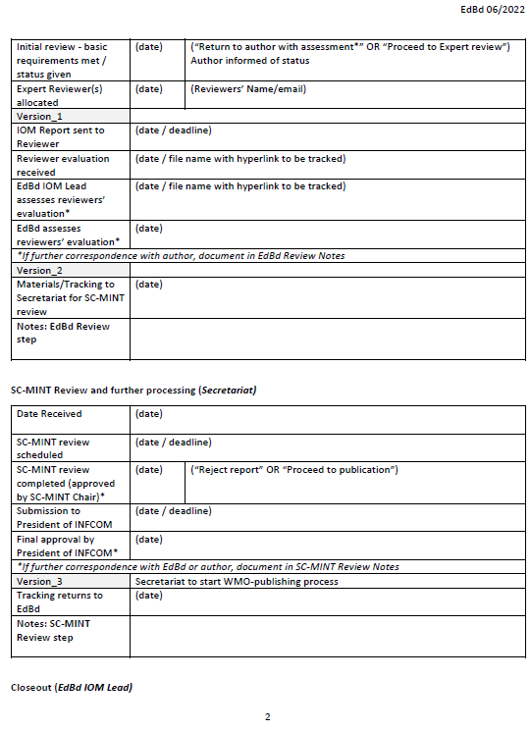

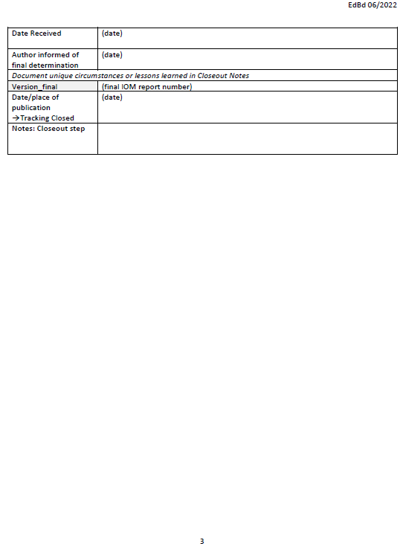
_______________

Boxes in the far left of the diagram indicate version numbering used in document tracking.

